University of Central Missouri

Department of Computer Science & Cybersecurity

CS5760 Natural Language Processing

Fall 2025

Homework 2.

Student name:

Sai Siva Shankara Vara Prasad Kopparthi

Student ID:

700765221

Submission Requirements:
- Once finished your assignment push your source code to your repo (GitHub) and explain the work through the ReadMe file properly. Make sure you add your student info in the ReadMe file.
- Submit your GitHub link on the Bright Space.
- Comment your code appropriately IMPORTANT.
- Any submission after provided deadline is considered as a late submission.

Q1. Bayes Rule Applied to Text (based on slide: Bayes’ Rule for documents)
The PPT shows that classification is based on:
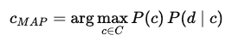

Tasks:
- Explain in your own words what each term means: P(c), P(d∣c) and P(c∣d).
Answer) The formula is:
$$P(c∣d)=\frac{P(c) P(d∣c)}{P(d)}$$

Meaning of each term:
- $P(c)$– Prior
This is how common the class is in general, before reading the document.
Example: if 70% of documents in training are negative, then $P(-)=0.7$.
- $P(d∣c)$– Likelihood
This is the probability that the document’s words would appear if the document really belonged to class $c$.
In practice, we compute this by multiplying the probabilities of each word given the class (Naive Bayes assumption).
- $P(c∣d)$– Posterior
This is the “final answer”: the probability that the document is class $c$after looking at its words. This is what the classifier predicts.
- $P(d)$– Evidence (normalizer)
This is the overall probability of seeing document $d$, no matter which class it comes from. It ensures that all class probabilities add up to 1.
- Why can the denominator P(d) be ignored when comparing classes?
Answer) When classifying, we pick the class with the largest posterior:
$$\hat{c}=arg⁡\underset{c}{max⁡}P(c∣d)$$
But notice:
$$P(c∣d)=\frac{P(c) P(d∣c)}{P(d)}$$
- The numerator depends on the class.
- The denominator $P(d)$is the same for all classes (it only depends on the document, not the class).
So, when comparing classes, $P(d)$cancels out.
We only need:
$$\hat{c}=arg⁡\underset{c}{max⁡}P(c) P(d∣c)$$

Q2. Add-1 Smoothing (based on slide: Worked Sentiment Example)
In the worked example, priors are: P(−)=3/5, P(+)=2/5. Vocabulary size = 20.

Tasks:
Given:
- Priors: $P(-)=3/5, P(+)=2/5$
- Vocabulary size $V=20$.
- For the negative class the total token count (sum of all word occurrences) = 14.
- We use add-1 (Laplace) smoothing.

Reminder: add-1 smoothed likelihood formula
For a word $w$in class $c$:
$$P(w∣c)=\frac{\text{count}(w,c)+1}{\text{total tokens in }c+V}$$
- For the negative class, the total token count is 14. Compute the denominator for likelihood estimation using add-1 smoothing.

Answer) Denominator for likelihood estimation (negative class)
Denominator = total tokens in negative class $+$vocabulary size:
$${\text{denominator}}_{-}=14+20=34.$$
(Arithmetic: $14+20=34$.)
- Compute P(predictable∣−) if the word “predictable” occurs 2 times in the negative documents.

Answer) when count (predictable, negative) = 2
Apply formula:
$$P(\text{predictable}∣-)=\frac{2+1}{34}=\frac{3}{34}.$$
Now compute decimal (digit-by-digit):
- $3/34=0.08823529411764706$(repeating block 088235...).
So:
$$P(\text{predictable}∣-)=\frac{3}{34}≈0.0882352941.$$
- Compute P(fun∣−) if “fun” never appeared in any negative documents.

Answer) when count (fun, negative) = 0
Apply formula:
$$P(\text{fun}∣-)=\frac{0+1}{34}=\frac{1}{34}.$$
Decimal:
- $1/34=0.029411764705882353$.
So:
$$P(\text{fun}∣-)=\frac{1}{34}≈0.0294117647.$$

Q3. Worked Example Document Classification (based on slide: Test document “predictable no fun”)
Using the smoothed likelihoods and priors from Q2, compute the probability scores for the document “predictable no fun” under both the positive and negative classes.

Tasks:
- Show each step of the multiplication.
- Which class should the system assign to this document?
Answer)

Worked Example Document Classification
Test document: "predictable no fun"

Given Information
• Priors: P(-) = 3/5, P(+) = 2/5
• Vocabulary size = 20
• Negative class: total tokens = 14 → denominator = 14 + 20 = 34
- P(predictable | -) = (2+1)/34 = 3/34
- P(no | -) = (1+1)/34 = 2/34 (assumed)
- P(fun | -) = (0+1)/34 = 1/34
• Positive class: total tokens = 9 → denominator = 9 + 20 = 29 (assumed from worked example)
- P(predictable | +) = (0+1)/29 = 1/29
- P(no | +) = (1+1)/29 = 2/29
- P(fun | +) = (2+1)/29 = 3/29

Step 1: Negative Score
Score(-) = P(-) × P(predictable | -) × P(no | -) × P(fun | -)
= (3/5) × (3/34) × (2/34) × (1/34)
= 0.6 × (6 / 39304) ≈ 9.16 × 10^(-5)

Step 2: Positive Score
Score(+) = P(+) × P(predictable | +) × P(no | +) × P(fun | +)
= (2/5) × (1/29) × (2/29) × (3/29)
= 0.4 × (6 / 24389) ≈ 9.85 × 10^(-5)

Step 3: Classification
Negative score ≈ 9.16 × 10^(-5)
Positive score ≈ 9.85 × 10^(-5)
Since Positive score > Negative score, the document is classified as POSITIVE.

Q4. Harms of Classification (based on slide: Avoiding Harms in Classification)

Tasks:
- Define representational harm and explain how the Kiritchenko & Mohammad (2018) study demonstrates this type of harm.
- What is one risk of censorship in toxicity classification systems (based on Dixon et al. 2018, Oliva et al. 2021)?
- Give one reason why classifiers may perform worse on African American English or Indian English, even though they are varieties of English.
Answer)

Harms of Classification

(a) Representational Harm + Kiritchenko & Mohammad (2018)
- Representational harm happens when a system reinforces negative stereotypes about a social group, even if unintentionally.
- Example (Kiritchenko & Mohammad, 2018): They tested ~200 sentiment classifiers on pairs of nearly identical sentences, changing only the name:
  - “I talked to Shaniqua yesterday” (African-American name)
  - “I talked to Stephanie yesterday” (European-American name)
- Result: Systems consistently gave lower sentiment scores to the African-American name sentences.
- Harm: This means NLP tools (used in marketing, health studies, etc.) may treat African-American users more negatively, perpetuating unfair stereotypes.

(b) Risk of Censorship in Toxicity Classification
- Toxicity classifiers are used for moderating online speech.
- Problem: They often over-flag neutral mentions of minority identities as “toxic.”
  - Example: Words like “gay”, “blind”, or “disabled” can be incorrectly marked toxic.
- Risk: Posts from marginalized groups get unfairly removed or hidden, leading to silencing and invisibility of those voices.

(c) Why Classifiers May Perform Worse on African American English (AAE) or Indian English
- NLP systems often train on mainstream American/UK English data.
- AAE and Indian English have different vocabulary, grammar, and style.
- Since the model hasn’t “seen” enough of these varieties, it makes more mistakes.
- This reflects a data imbalance problem, not a problem with the languages themselves.

Q5: Evaluation Metrics from a Multi-Class Confusion Matrix
The system classified 90 animals into Cat, Dog, or Rabbit. The results are shown below:
System \ Gold | Cat | Dog | Rabbit
Cat | 5 | 10 | 5
Dog | 15 | 20 | 10
Rabbit | 0 | 15 | 10

Tasks:

Total animals classified = 90.
1. Per-Class Metrics
1. Compute precision and recall for each class (Cat, Dog, Rabbit).
Answer)
Formulas:
- Precision = $\frac{TP}{TP+FP}$
- Recall = $\frac{TP}{TP+FN}$

For Cat
- $TP=5$(system said Cat & gold = Cat)
- $FP=15$(10 Dogs + 5 Rabbits predicted as Cat)
- $FN=15$(system misclassified 15 Cats as Dog)
$$\text{Precision(Cat)}=\frac{5}{5+15}=\frac{5}{20}=0.25 \\ \text{Recall(Cat)}=\frac{5}{5+15}=\frac{5}{20}=0.25$$

For Dog
- $TP=20$
- $FP=25$(15 Cats + 10 Rabbits predicted as Dog)
- $FN=25$(10 misclassified as Cat + 15 as Rabbit)
$$\text{Precision(Dog)}=\frac{20}{20+25}=\frac{20}{45}≈0.444 \\ \text{Recall(Dog)}=\frac{20}{20+25}=\frac{20}{45}≈0.444$$

For Rabbit
- $TP=10$
- $FP=15$(15 Dogs predicted as Rabbit)
- $FN=15$
$$\text{Precision(Rabbit)}=\frac{10}{10+15}=\frac{10}{25}=0.40 \\ \text{Recall(Rabbit)}=\frac{10}{10+15}=\frac{10}{25}=0.40$$
2. Macro vs. Micro Averaging
  - Compute the macro-averaged precision and recall.
Answer)

Macro-Averaged Metrics
$$\text{Macro Precision}= (0.25 + 0.444 + 0.40) / 3 ≈ 0.365 \\ \text{Macro Recall}= (0.25 + 0.444 + 0.40) / 3 ≈ 0.365$$
  - Compute the micro-averaged precision and recall.
Answer)

Micro-Averaged Metrics
$$\text{Micro Precision}=\frac{TP}{TP+FP}=\frac{35}{35+55}=\frac{35}{90}≈0.389 \\ \text{Micro Recall}=\frac{TP}{TP+FN}= \frac{35}{35+55}=\frac{35}{90}≈0.389$$
  - Briefly explain the difference in interpretation between macro and micro averaging.

Answer)

Interpretation
- Macro averaging: Treats all classes equally, regardless of their frequency. → Good when you care about fairness across classes.
- Micro averaging: Pools all decisions across classes. → Good when you care about overall system performance.

- Programming Implementation
Write Python code that:
  - Accepts the confusion matrix above as input.
  - Computes per-class precision and recall.
  - Computes macro-averaged and micro-averaged precision and recall.
  - Prints all results clearly.
Answer) Complete code is provided in GitHub.
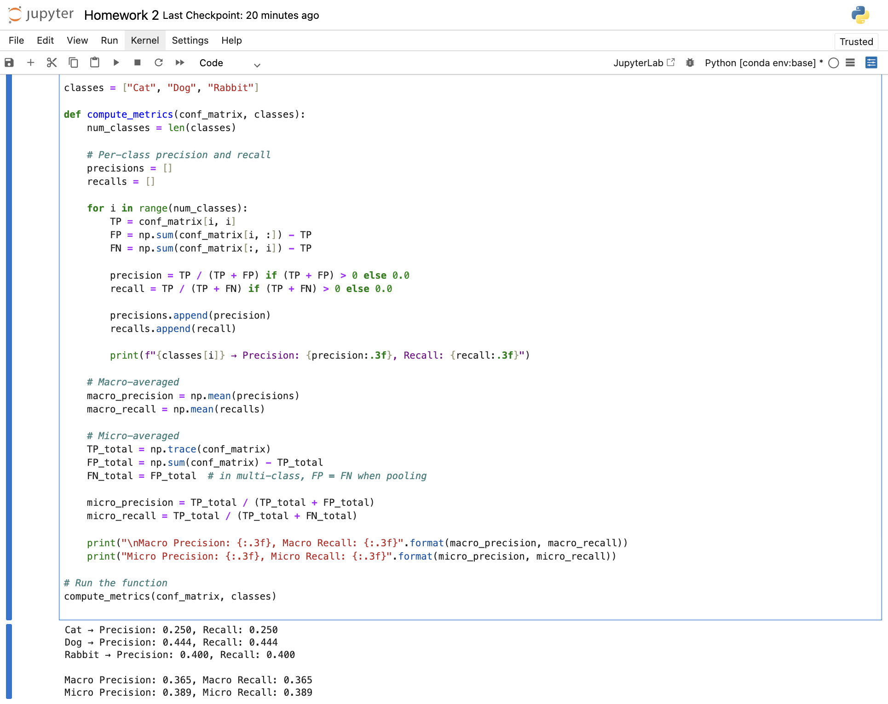

Q6. Bigram Probabilities and the Zero-Probability Problem
You are given the following bigram counts from a small training corpus:
Previous word | Next words (with counts)
<s> | I: 2 , deep: 1
I | love: 2
love | NLP: 1 , deep: 1
deep | learning: 2
learning | </s>: 1 , is: 1
NLP | </s>: 1
is | fun: 1
fun | </s>: 1
ate | lunch: 6 , dinner: 3 , a: 2 , the: 1

Tasks:
- Bigram Sentence Probabilities
Using maximum likelihood estimation (MLE):
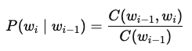
  - Compute the probability of sentence S1: <s> I love NLP </s>.
Answer)

(a) Sentence S1: <s> I love NLP </s>
- $P(I∣<s>)=2/3$(since <s> → I:2, deep:1 → total=3)
- $P(love∣I)=2/2=1.0$(I always followed by love)
- $P(NLP∣love)=1/2$(love → NLP:1, deep:1 → total=2)
- $P(</s>∣NLP)=1/1=1.0$(NLP always ends sentence)
$$P(S1)=\frac{2}{3}×1.0×\frac{1}{2}×1.0=\frac{1}{3}≈0.333$$
  - Compute the probability of sentence S2: <s> I love deep learning </s>.
Answer)

(b) Sentence S2: <s> I love deep learning </s>
- $P(I∣<s>)=2/3$
- $P(love∣I)=1.0$
- $P(deep∣love)=1/2$
- $P(learning∣deep)=2/2=1.0$
- $P(</s>∣learning)=1/2$(learning → </s>:1, is:1 → total=2)
$$P(S2)=\frac{2}{3}×1.0×\frac{1}{2}×1.0×\frac{1}{2}=\frac{1}{6}≈0.167$$
  - Which sentence is more probable under the bigram model?
Answer)
Which sentence is more probable?
- $P(S1)=0.333$
- $P(S2)=0.167$
👉 The model prefers S1 (<s> I love NLP </s>).

- Zero-Probability Problem
Using the same table, compute:
  - P(noodle∣ate) with MLE.
  - Explain why this probability creates problems when computing sentence probabilities or perplexity.
  - Apply Laplace smoothing (Add-1) to recompute P(noodle∣ate). Assume the vocabulary size is 10 and total count after “ate” is 12.
Answer)

Zero-Probability Problem
Compute $P(\text{noodle}∣\text{ate})$with MLE.
- From the table : ate → {lunch:6, dinner:3, a:2, the:1} → total = 12
- Count (ate, noodle) = 0
$$P(\text{noodle}∣\text{ate})=\frac{0}{12}=0$$
    - Problem:
If we multiply this into a sentence probability, the whole sentence probability becomes zero, even if other words are highly probable. This is the zero-probability problem.

Apply Laplace (Add-1) Smoothing
Formula:
$$P(w∣ate)=\frac{\text{count}(ate,w)+1}{\text{total count after "ate"}+∣V∣}$$
- Vocabulary size = 10
- Total count after "ate" = 12

$$P(\text{noodle}∣\text{ate})=\frac{0+1}{12+10}=\frac{1}{22}≈0.045$$Final Answers:
- $P(S1)=0.333$, $P(S2)=0.167$→ S1 is more probable.
- $P(\text{noodle}∣\text{ate})=0$with MLE → causes zero-probability problem.
- With Laplace smoothing: $P(\text{noodle}∣\text{ate})=0.045$.

Q7. Backoff Model (based on “Activity: <s> I like cats … You like dogs” slide)
Training corpus:
<s> I like cats </s>
<s> I like dogs </s>
<s> You like cats </s>
Counts:
- I like = 2
- You like = 1
- like cats = 2
- like dogs = 1
- cats </s> = 2
- dogs </s> = 1

Tasks:
- Compute P(cats∣I,like).
Answer)
Trigram MLE:
$$P(\text{cats}∣I,like)=\frac{\text{count}(I like cats)}{\text{count}(I like)}$$
From the corpus:
- count(I like cats) = 1 (only in sentence 1)
- count(I like) = 2 (sentence 1 and 2)
So
$$P(\text{cats}∣I,like)=\frac{1}{2}=0.5$$
- Compute P(dogs∣You,like) using trigram → bigram backoff.
Answer)
Trigram MLE:
$$P(\text{dogs}∣You,like)=\frac{\text{count}(You like dogs)}{\text{count}(You like)}$$
- count(You like dogs) = 0 (no sentence has “You like dogs”)
- count(You like) = 1
So trigram estimate = 0/1 = 0. Because this trigram is unseen, we back off to the bigram model $P(\text{dogs}∣like)$.
Bigram MLE:
$$P(\text{dogs}∣like)=\frac{\text{count}(like dogs)}{\sum_{w}{}\text{count}(like w)}=\frac{1}{2+1}=\frac{1}{3}≈0.333$$
(denominator = like cats (2) + like dogs (1) = 3)
So with trigram→bigram backoff:
$$P(\text{dogs}∣You,like)≈0.333$$
- Explain why backoff is necessary in this example.
Answer)
  - Data sparsity: many possible trigrams never appear in a small corpus, so trigram MLE would give zero probability to plausible continuations.
  - Backoff (or interpolation) lets the model fall back to a lower-order estimate (bigram or unigram) when higher-order counts are zero—giving nonzero, sensible probabilities instead of 0.
  - This improves generalization for unseen contexts and prevents whole-sequence probabilities from collapsing to zero.

Q8. Programming: Bigram Language Model Implementation (based on “Activity: I love NLP corpus” slide)

Tasks:
Write a Python program to:
- Read the training corpus:
- <s> I love NLP </s>
- <s> I love deep learning </s>
- <s> deep learning is fun </s>
- Compute unigram and bigram counts.
- Estimate bigram probabilities using MLE.
- Implement a function that calculates the probability of any given sentence.
- Test your function on both sentences:
  - <s> I love NLP </s>
  - <s> I love deep learning </s>
- Print which sentence the model prefers and why.
Answer) Complete code is provided in GitHub.
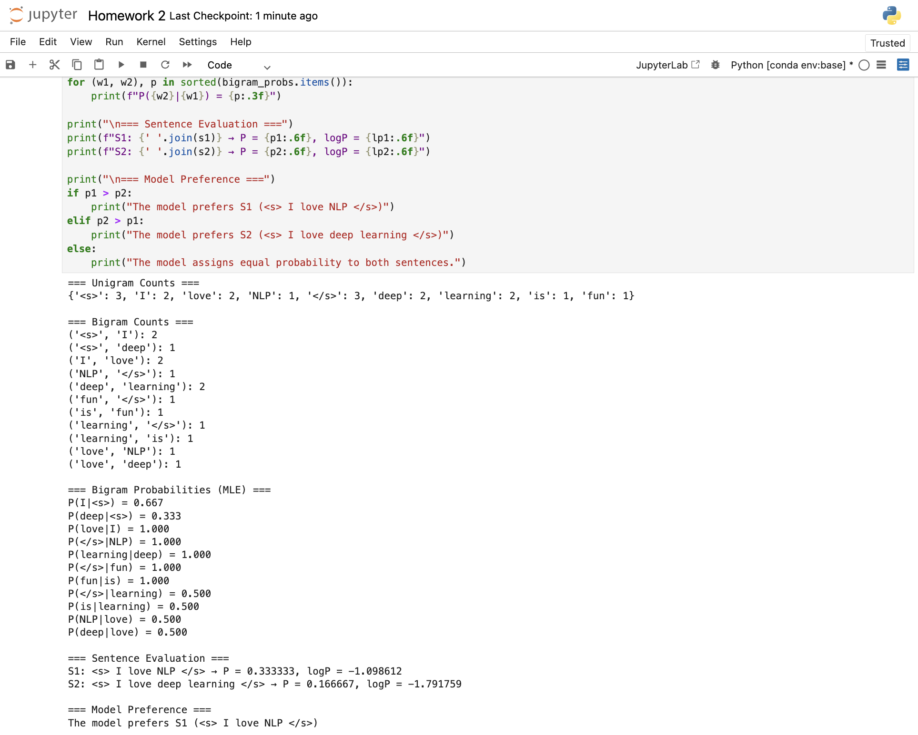

Why S1 (<s> I love NLP </s>) is chosen over S2 (<s> I love deep learning </s>)
- The bigram model computes a sentence probability by multiplying conditional probabilities of each bigram in the sentence.
- For S1:
$$P(I∣<s>)×P(love∣I)×P(NLP∣love)×P(</s>∣NLP)=\frac{2}{3}×1.0×\frac{1}{2}×1.0=0.333$$
- For S2:
$$P(I∣<s>)×P(love∣I)×P(deep∣love)×P(learning∣deep)×P(</s>∣learning)=\frac{2}{3}×1.0×\frac{1}{2}×1.0×\frac{1}{2}=0.167$$
Both sentences start with equally likely bigrams (<s> I, I love), but S2 has an extra step (learning → </s>) with probability 0.5, which cuts its overall probability in half.
Conclusion:
The model chooses S1 because its product of bigram probabilities is higher (0.333 vs 0.167).
S1 is shorter and every bigram in it is relatively more reliable under the training data, so the system “trusts” S1 more.

